1 Figure 1.1 shows the alimentary canal and associated organs.

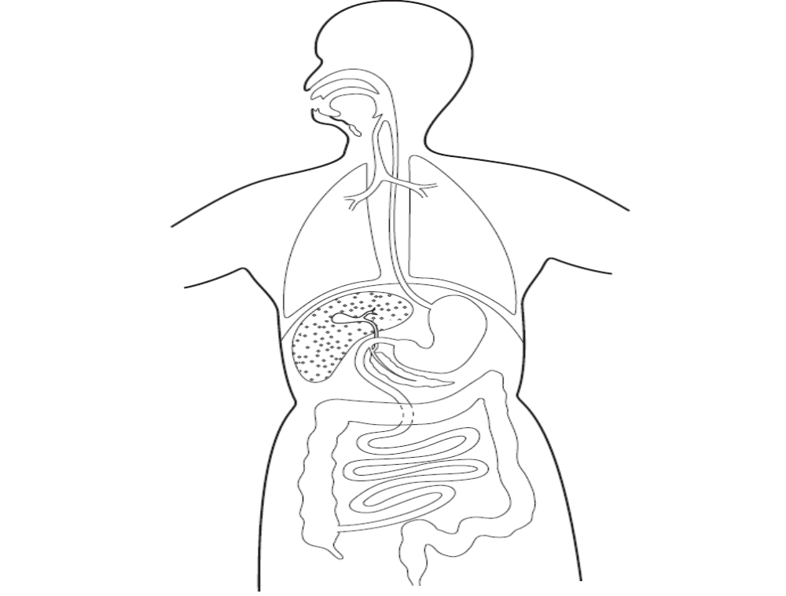
Fig. 1.1
a: On Fig. 1.1, identify and name the parts where each of the following processes/events occur. [5]

i: absorption of water
ii: completion of digestion
iii: storage of undigested matter
iv: initiation[beginning] of protein digestion
v: absorption of digested nutrients

b: Why is it necessary for our food to be digested? [2]
………………………………………………………………………………………………………………………………………………………………………………………………………………………………………………………………………………………………………………………

2 Table 2.1 shows the masses of various substances in 100 g of banana fruit and in 100 g of avocado fruit.
Table 2.2 shows a person’s recommended daily intake for calcium, iron and vitamin C.
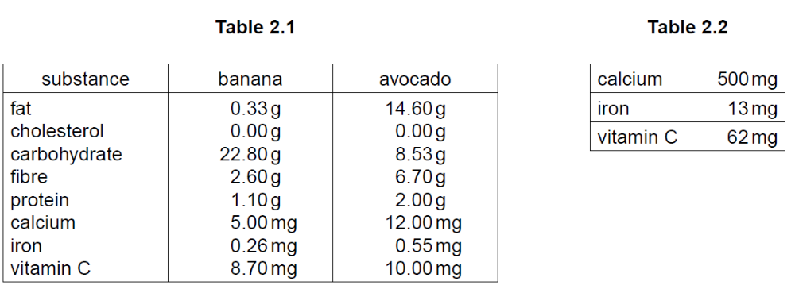
Bananas form a significant part of the diet of some communities.
(a) Explain why bananas can be a valuable part of a person’s diet.
............................................................................................................................................................
............................................................................................................................................................
............................................................................................................................................................
...................................................................................................................................................... [4]
(b) Explain why a diet of only bananas is not suitable for a growing child.
............................................................................................................................................................
............................................................................................................................................................
............................................................................................................................................................
............................................................................................................................................................
...................................................................................................................................................... [3]
(c) Explain which of the two fruits, banana or avocado, it would be better to eat just before running a race.
............................................................................................................................................................
............................................................................................................................................................
............................................................................................................................................................
...................................................................................................................................................... [3]

3 Fig. 3.1 shows two test-tubes, A and B, both containing water.
Each test-tube also contains a length of partially permeable Visking tubing that has been sealed at both ends.
The Visking tube in A contains a suspension of starch.
The Visking tube in B contains a suspension of starch and saliva.
[saliva contains a human enzyme which digests starch into maltose; a reducing sugar]
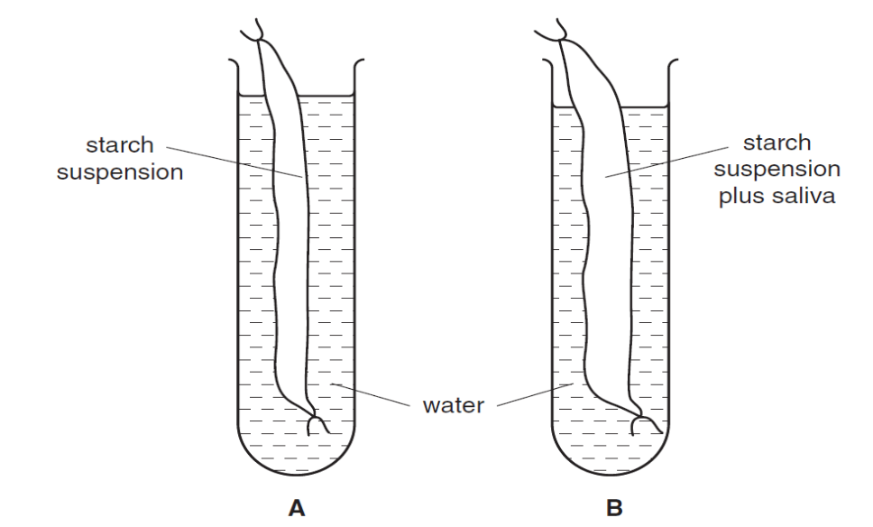
Fig. 3.1
The apparatus was left for twenty-four hours.
After that time, samples of water from each test-tube and samples of solution from each Visking tube were tested for starch and reducing sugar.
(a) Describe, giving practical details, how you would carry out a test for starch and a test for reducing sugar. State the positive result for each test.
starch test ..........................................................................................................................................
positive result .............................................................................................................................. [1]
reducing sugar test ............................................................................................................................
............................................................................................................................................................
............................................................................................................................................................
positive result .............................................................................................................................. [3]

(b) Complete Table 3.1, by predicting the results that you would expect from the experiment shown in Fig. 3.1.
Table 3.1
