
The City School
University Road Campus
SCIENCE GRADE 6
REINFORCEMENT WORKSHEET
PLANT GROWTH
MULTIPLE CHOICE QUESTIONS
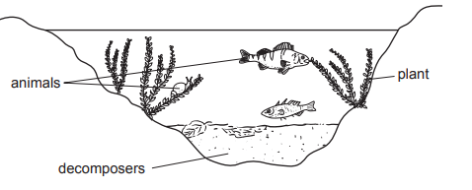
1.The diagram shows some organisms living in water.

Which process is carried out by all living organisms shown?
- Photosynthesis
- Pollination
- Respiration
- Transpiration

- What does photosynthesis forms in leaf first?
- Cellulose
- Protein
- Starch
- Sugar

- Carbon dioxide enters a leaf of a plant via
- Stomata
- Roots
- Stems
- Flowers

- Fertilizers which come from living things like animal dung, compost, fish and bone meals are:
- Organic Fertilizer
- Inorganic Fertilizer
- Low Fertilizer
- Complex Fertilizers.
Q1. (a) (i) Name the two raw materials needed by plants for photosynthesis.
------------------------------------------------------------------------------------------------------------------------------------------
(ii) Name the gas produced during the process of photosynthesis.
------------------------------------------------------------------------------------------------------------------------------------------
(iii) The figure shows a leaf with white and green regions , that is attached to a plant. The plant had been kept in the dark for 48 hours and then a light proof black paper cover was placed over a part of the leaf
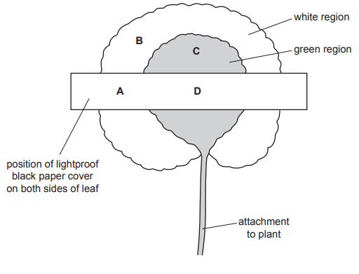

- The plant was kept in sunlight for a few hours after which the cover was removed and starch test was performed. Fill the following table showing if starch was present or not.

Area | Starch Present
A
B
C
D

b)-Explain the reasoning for your answers in (i) for the following areas:

Area A: ______________________________________________________________________________________________________________________________________________________

Area C:
______________________________________________________________________________________________________________________________________________________

Area D:
______________________________________________________________________________________________________________________________________________________

