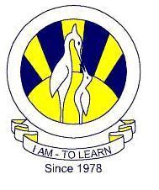The City School

University Road Campus
2nd Term
Mathematics
Class 6
Reinforcement Worksheet (Functions and Graphs)
Name: __________________ Sec: _______ Date: _______________

Coordinate grid Worksheet 1

1 a. 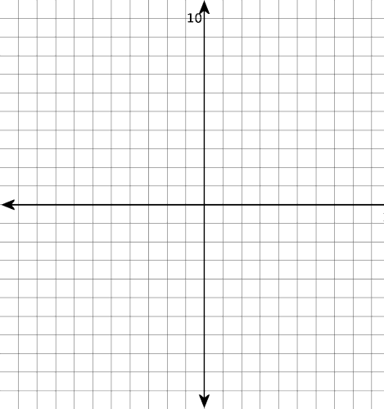  Plot the points (-9, 7), (-1, 10),  (6, 7), (7, -6), and (-6, -7), and  join them to get a shape. What shape is it? | 1 b. 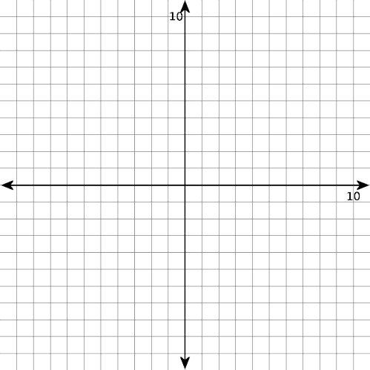  Plot the points (-8, 10), (0, 10), (0, -  3), and (-8, -3), and join them to get a shape. What shape is it?
2 a.  Plot the following points: (-1, 0),  (-10, 4), (10, -2), and (-6, 10). | 2 b.  Plot the points (0, 6), (2, 10), (10, -1), and (-9, -8), and join them to get a shape. What shape is it?

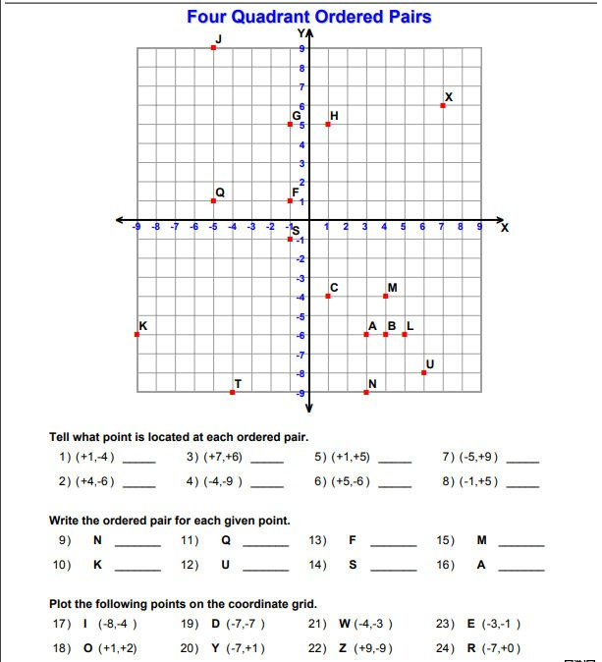

Coordinate grid Worksheet 2

