
The City School
University Road Campus – Matric Section
Pre-Board Examination 2019-20
Index Number: ________________________________

Subject: Islamiat Class: 10 Sec: __________
Date: ___________________ Time: 3 Hours

Read these Instructions First:
- Write your school name and index number in the space provided above.
- Carefully read and follow the instructions given for each question.
- All the answers must be written in the answer sheet.
- Check your answers before you return the question paper to the invigilator.

……………. For Examiner’s use only…………….

Section | Section: A  Compulsory | Section: B  Short Q/A | Section: C  Detail Q/A | Total Marks | Percentage  % | Grade
Max Marks | 15 | 36 | 24 | 75
Obtained Marks

_____________________ __________________ __________________
Invigilated by Checked by Marks Tallied by

Section “A” (Multiple choice questions)
/15

Q1. Choose the Correct answer.
- The jewish tribe which helped the Quraysh in the battle of Ahzab was:
a) Banu Qurayza b) Banu Makhzoom c) Banu Nadir d) Banu Qainuqa
- It is necessary for a women to talk with a men she should not be:
a) Lenient in her accent b) Strict in her accent c) Polite in her speech d) Rude in her speech
- The spoils of war belongs to:
- The needy and the indigent b) Allah and his messenger c) Relatives of the martyrs c) d) None of
them
- Allah helped the Muslims in the battle of Badr:
a) By three thousand angels b) By two thousand angels c) By one thousands angels d) By four thousand angels
- The day on which battle of Badr was fought is called by the Quran:
a) Yawmul Quran b) Tawm-e-Aashura c) Yawul Malhama d) Yawmul furqan
- The Muslims who migrate are called:
a) Muhajireen b) Ansar c) Quraysh d) True Muslims
- To obtain knowledge is:
a) Mustahab preferable b) Wajib secondary imperative pm Muslims
c) Obligatory on Muslims d) Sunnah for Muslims
- The best among you us the one who:
a) Adopts piety and call others to good deeds b) Gains knowledge and acts upon it
c) Learns the Quran and teaches it to other d) None of these
- The Quran was revealed on the Prophet (Peace be upon him):
a) In 22 years b) In 21 years c) In 24 years d) In 23 years
- Seeking knowledge is obligatory on:
a) Only men b) men and women both c) Only women d) On all creatures
- According to Hadith educational gatherings are:
a) Fruits of paradise b) Gardens of paradise c) Both of them d) Path of paradise
- Zakat is obligatory on:
a) Every wealthy person b) Only on Sahib-e-Nisab c) Every Muslim d) Every Pilgrim
- The Holy Quran explained the of recipients Zakat:
a) 8 b) 10 c) 4 d) 6
- We have to wash every part according to of the Prophet:
a) Three times b) One times c) Two times d) Four times
- The responsibilities of the welfare of a family is:
a) On man b) On paternal grandfather c) On women d) On parents

Section “B” (Short Answer Questions)
/36

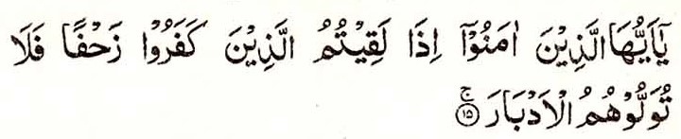
Q2. Translate any five of the following. /10
- /
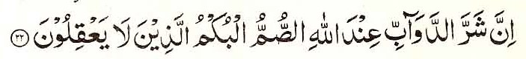
- /

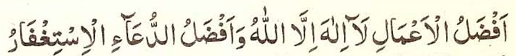
- /
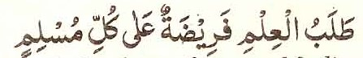
- /

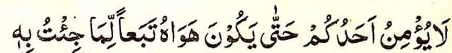
- /
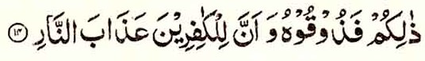
- 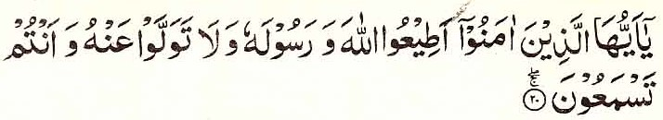/

- /
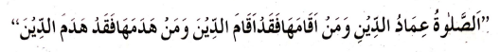

Q3. Answer any six of the following /18
- Which four principles are described in hadith for the completion of faith?
- What one of the two options were offered to holy Prophet’s wives in Surah Ahzab?
- What are the two joys of fasting?
- According to hadith what is the reward for a believer who bears the hardships for the cause of Allah?
- What divine instructions are given in Surah Anfal about war prisoners?
- Why does Quran call marital relation an Ehsan?
- What is stated about المعوقین in Surah Ahzab.
- What should be the response of Muslims with infidels in the light of Surah Mumtahina?
Q4. Explain any four of the given terminologies /08
- Zihar
- Family life
- Jihad
- Cleanliness
- Patience
- شرالدوآب

Section “C” (Descriptive Answer Questions)
/24
Q5. Translate any Three of the following.
- Describe about the belief of finality of prophet hood in detail.
- What is meant by love and obedience of Allah in the light of Quran and Hadith?
- Write meanings, importance and uses of Zakat?
- What do you know about rights and duties of husband and wife (Zojain) an each other?
- What do you know about preservation of Holy Quran?

