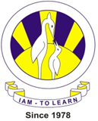
The City School
University road Campus
Class 4 -Science
Worksheet

Q.1 Fill in the missing spaces with the words from the light bulb below.
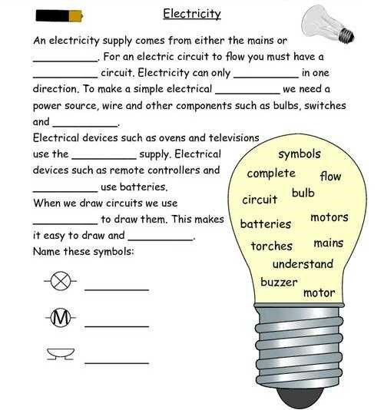
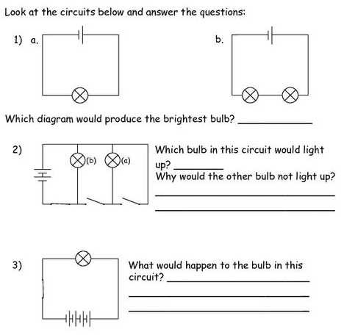
Q
.
6

