
The City School
Jinnah Campus
Class 4 -Science
Revision Worksheet

Q.1 Solve the crossword.
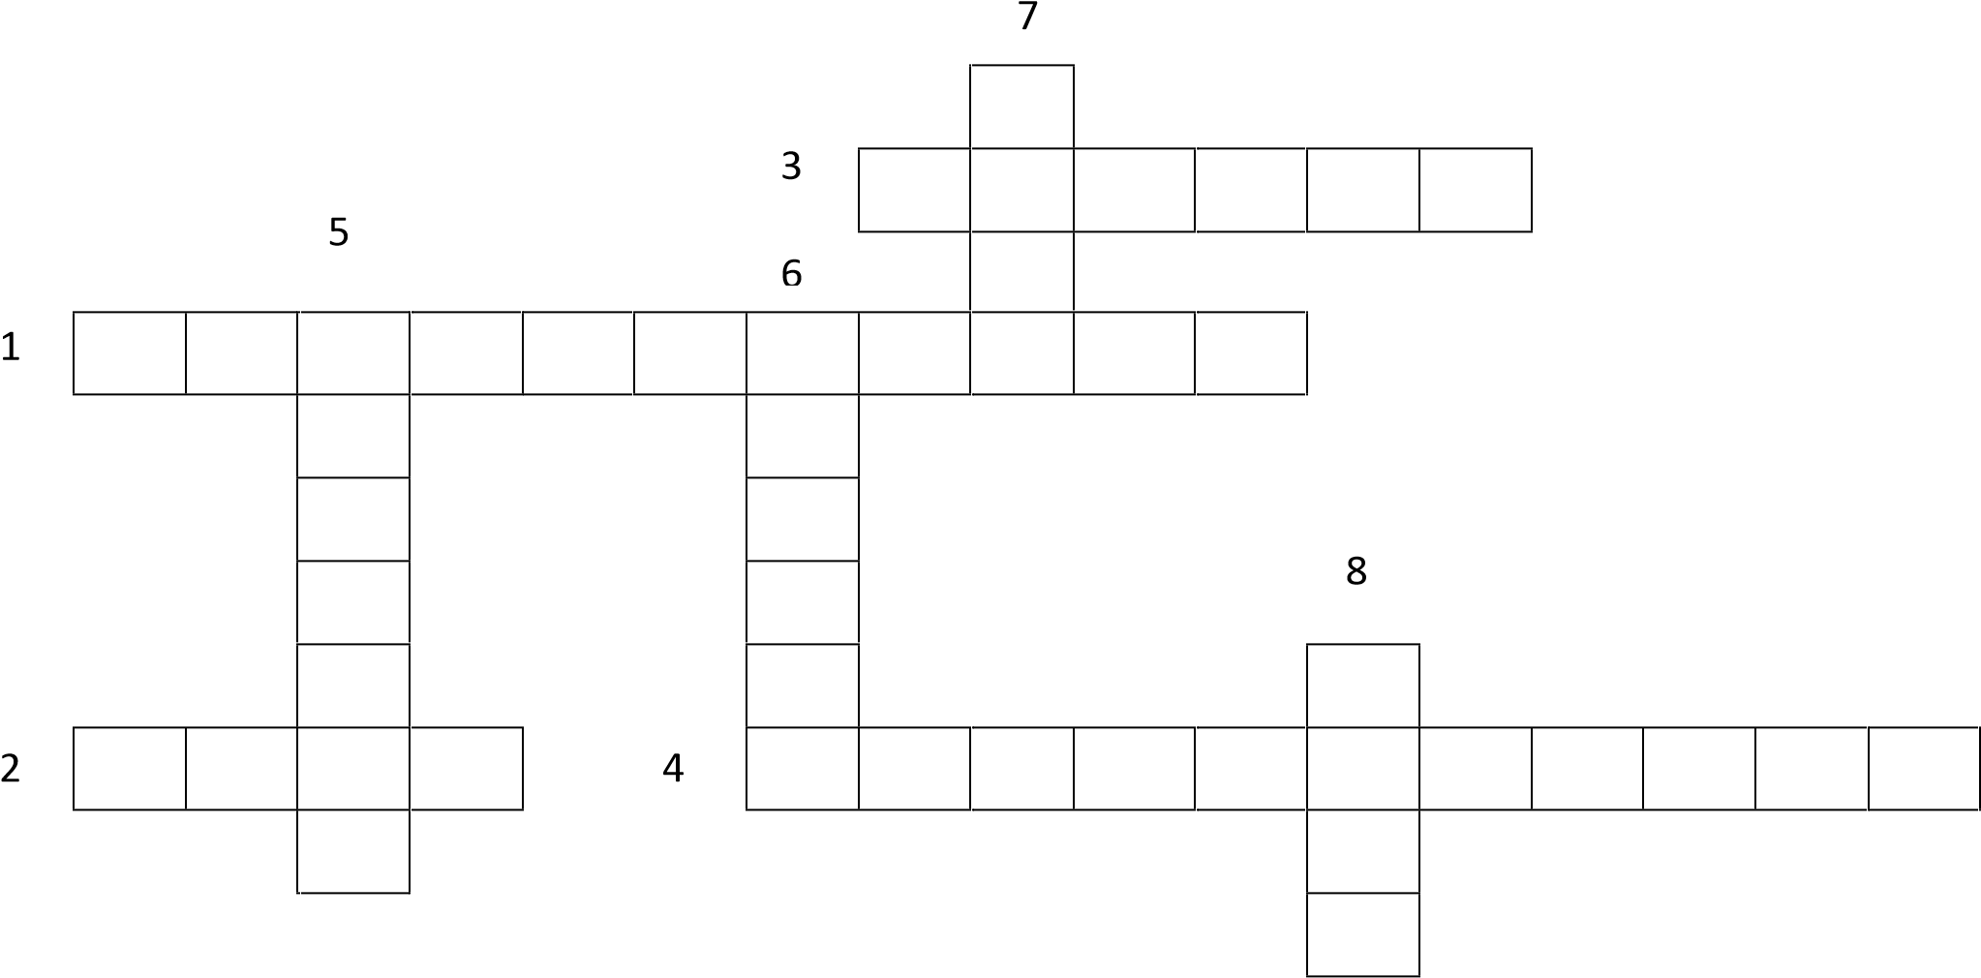
Across:
1. An instrument used to measure temperature. 2. The temperature of our ___________ is 37°C.
    - The units for temperature are _____________ Celsius.
    - Things heat up or cool down until they have temperature as their _______________.
Down:
    - When something gets bigger it ____________________.
    - ______________ are good thermal conductors.
    - Thermal conductors allow ___________ to go through it easily.
    - The rounded end at the bottom of a thermometer.

Q.2a Below is a graph showing the results of an experiment conducted by the students of class 4 on hot chocolate.
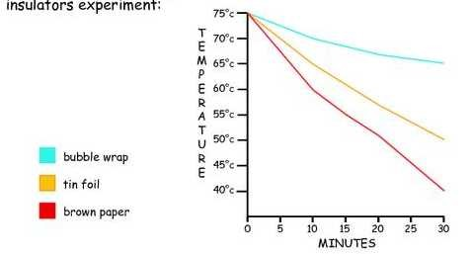
Bubble wrap
Tin foil
Brown paper
      - Which insulator worked the best? __________________________
      - What was the temperature of hot chocolate wrapped in bubble wrap after 30 minutes? _________________________
      - Which insulator was the least effective? _________________________
      - What was the temperature of hot chocolate wrapped in tin foil after 30 minutes? _________________________
      - What was the temperature of hot chocolate wrapped in brown paper after 30 minutes? _________________________
b. What happens to liquid inside the thermometer when it is kept in hot water?
_____________________________________________________________________________
_____________________________________________________________________________ _____________________________________________________________________________

