The City School
University Road Campus
Science Reinforcement Worksheet Topic: attracting and repelling
Name: ______ Class: 3 Sec: _________ Date:_______

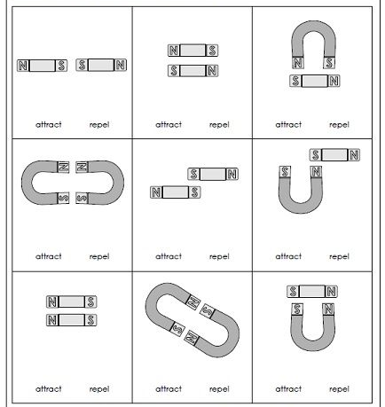
Q1: Tell whether each pair of magnets can attract or repel?

Q2: Sort the given pictures to magnetic and nonmagnetic materials.
Magnetic materials | Non-magnetic materials

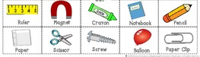

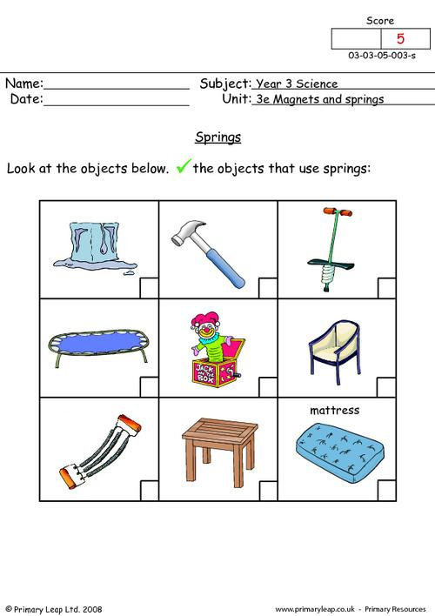
Q1: Look the objects below, tick the objects that use spring in it.

