
The City School
University Road Campus
Class 2 -- Science
Name: ___________________________ Section: ______ Date: ______________
Topic: Natural and Man-Made Materials
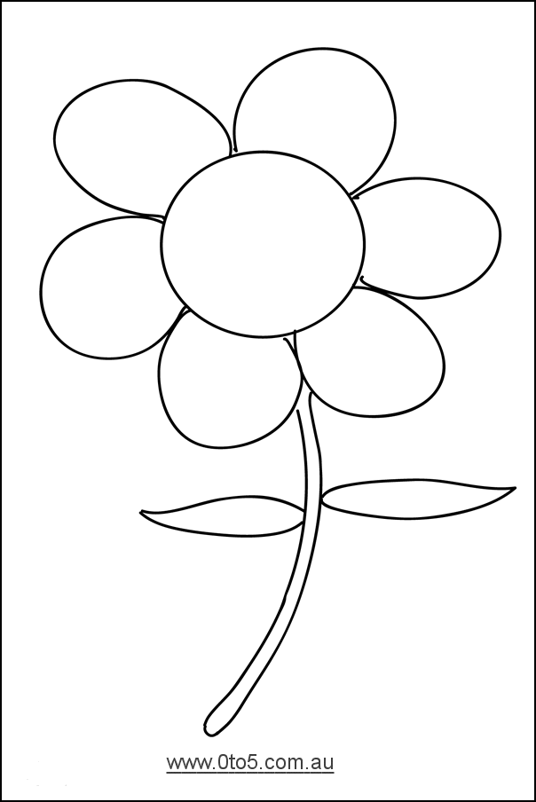
- Give Examples of natural and man-made materials.

Natural Materials

Man-Made Materials

The City School
University Road Campus
Class 2 -- Science
Name: ___________________________ Section: ______ Date: ______________
Topic: States of Matter
- Cut and paste the word in correct column.
Solid | Liquid | Gas

air | water | juice | door | milk
smoke | river | brick | tree | table
rock | apple | wind | rain | stream

The City School
University Road Campus
Class 2 -- Science
Name: ___________________________ Section: ______ Date: ______________
Topic: Changing Materials
- Investigate how things change when they are cooled.

Things | Will it change? What I think will happen? | What actually happened?
Water
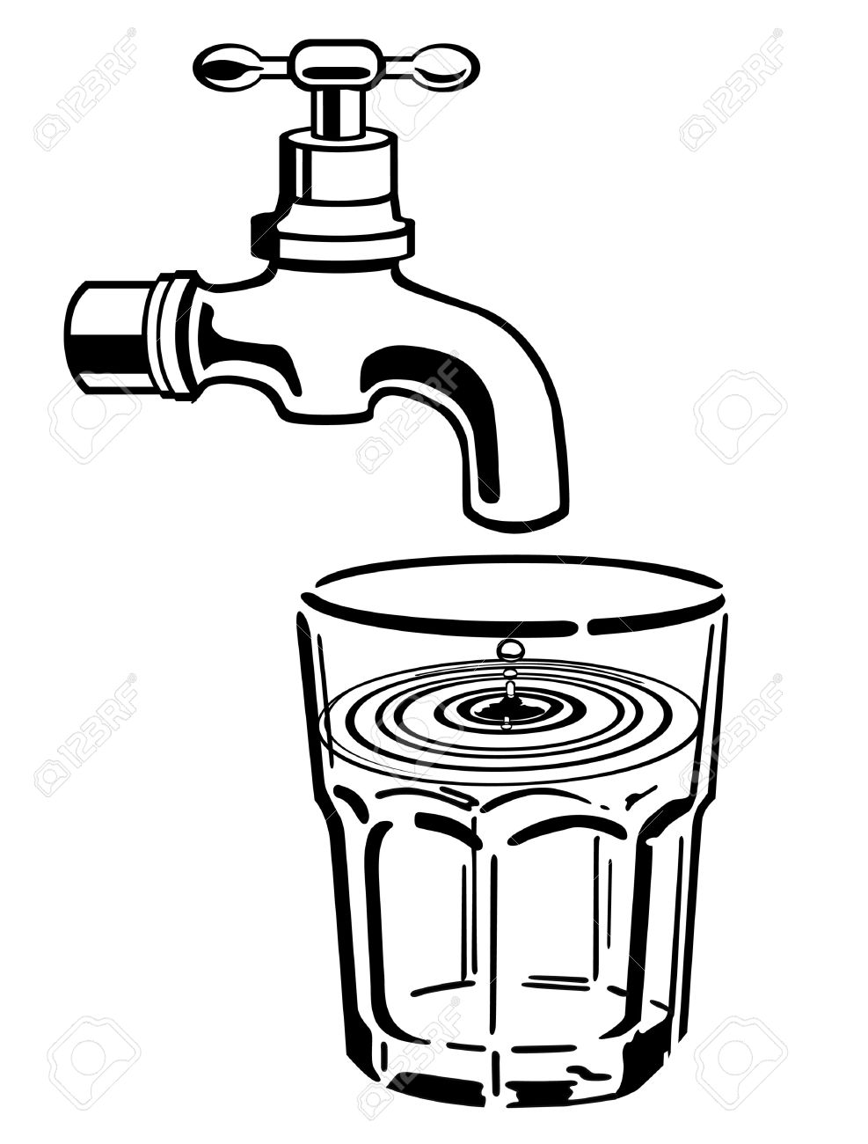
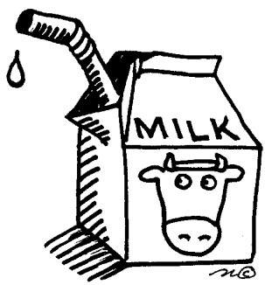
Milk
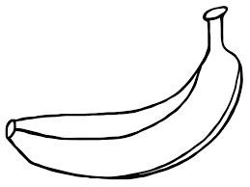
Banana
The City School
University Road Campus
Class 2 -- Science
Name: ___________________________ Section: ______ Date: ______________
Topic: Soluble and Insoluble Materials
https://www.youtube.com/watch?v=DodP0t2aZKI
- Define soluble materials in your own words.

________________________________________________________________________________________________________________________________________________________________________________________________________________________________________________________________________________________________________________________________
Examples:
1. ________________________
2. ________________________
3. ________________________
- Define insoluble materials in your own words.

________________________________________________________________________________________________________________________________________________________________________________________________________________________________________________________________________________________________________________________________
Examples:
1. ________________________
2. ________________________
3. ________________________

