The City School
University road Campus
Class 2 English worksheet
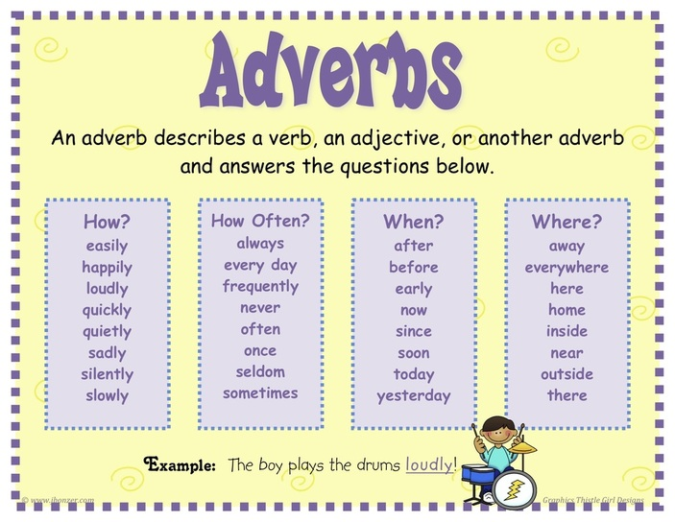
Topic: Adverbs
Q. Read each sentence below and circle the word that describes how the action happened.
1. The snail slithered slowly down the path.
2. The wind blew softly through the trees.
3. The kids ran quickly during the race.
4. Susan writes neatly.
5. The students played outside.
6. My mother will soon be here.
7. I went for jogging yesterday.
8. Tom wakes up early in the morning.
9. Jerry ran outside to make a snowman.
10.We often go to school together.
11. Tomorrow, I will go to the dentist.
12. David quickly finished his homework, so he could play outside.

