
The City School
University Road Campus

Reinforcement Worksheet
Class 2
Mathematics

Q1: Write the following numbers according to their place value also write their
number names also.

a: 256
=
+
+
200
50
6

________________________________________________

b: 378
=
+
+

_____________________________________________________

Q2a) Partition and add the following numbers.
- 35 + 23 =

=
+

Q2 b): Partition and subtract the following numbers.
63 - 45 =
=
+

Q3: Complete these:
- 50 b) 70

30 + ____________ 50 + ____________

40 + ____________ 10 + ____________

Q4a: Colour half circle with red and quarter square with blue. And write the fractions.

Q4b: Draw a loop to find ½ and ¼ of these.

- ½ of 8 = ______ b) ¼ of 12 =

Q5: Draw hands on the clocks according to the given time.
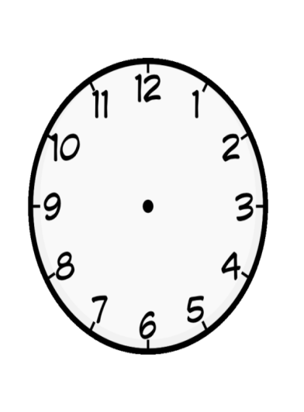

5: 10
____minutes past ______
5:35
____minutes past ______
8: 25
____minutes past ______

Q6: Solve these:
- 45 + 6 = ________ b ) 54 + 4 = _____ c) 36 – 5 =______

d) 85 – 20 =______ e) 45 + 30 =______ f ) 75 + 10=______

g) 32 + 10 =_______ h) 50 + 30 =______ i) 75 – 15 =______

j) 65 - 15 =______ k) 55 – 20 =______ l) 80 – 40=_____-

