
The City School
University Road Campus
History
Question Bank
Name: ___________________ Class: 6 Section: _______ Date: ______________
Instructions to follow:
- Use the back of learning journals to write your answers
- Avoid coping text as it is from the book. Always Rephrase
- Please remember all these questions meant for practice only so students will be able to prepare themselves for examination point of view
- TIME SPAN per question is mentioned. You are requested to follow that strictly
Section A
Q: Who am I? makrs 8
Time: 4 - 6 mins
I was an ambition ruler who conquered the greatest part of Greece in 338BC and the father of most famous general of Greek conqueror. Who am I?
_____________________________________________________________________________________
We are the strong, tough and well trained people who guarded the Roman Empire.
_____________________________________________________________________________________
We are the leaders of the city, elected by the senate and the top position holder of the Roman Empire.
_____________________________________________________________________________________
We are the one who wrote books on History and Geography for the first time. Who are we?
_____________________________________________________________________________________
I am the one who in 33CE, under the pressure of Jewish religious leaders ordered the crucifixion of Jesus Christ.
_____________________________________________________________________________________
I am known as a father of History. Who am I?
_____________________________________________________________________________________
Greeks consider me King of gods, lived in mount Olympus in the north of Greek. Who am I?
_____________________________________________________________________________________
I was the Byzantine emperor (306 – 337ce), built many churches and gave favor to Christianity. Who am I?
_____________________________________________________________________________________

Q: Picture Source
Page 49, Fig 10.2 makrs 10
Time requires 10 min
- Name the place shown in the picture?
- Describe its location and how long it is?
- What the purpose of making it?
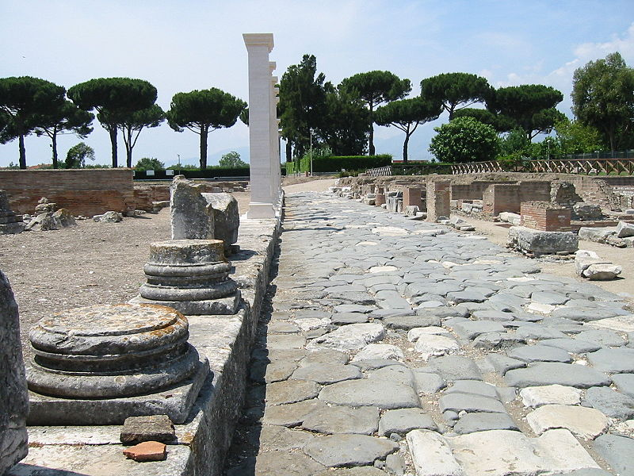
Page 50, Fig 10.5 makrs 10
Time requires 10 mins
- Identify the given source?
- Where it is currently located?
- How it was honored by the people of its country?
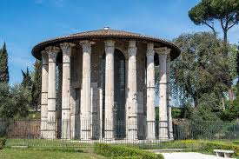
Page 45, Fig 9.3 makrs 10
Time requires 10 mins
- Identify the given personality and why was he known for?
- Pen down 3 contributions of the given personality?
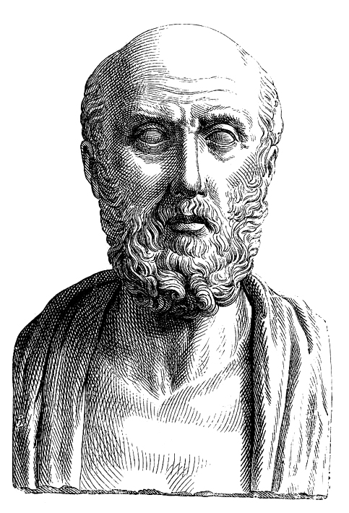
Page 56, Fig 11.4 makrs 10
Time requires 10 mins
- Identify the given source and where it is currently located?
- Why the given source famous for?
- What is the importance of the given source?
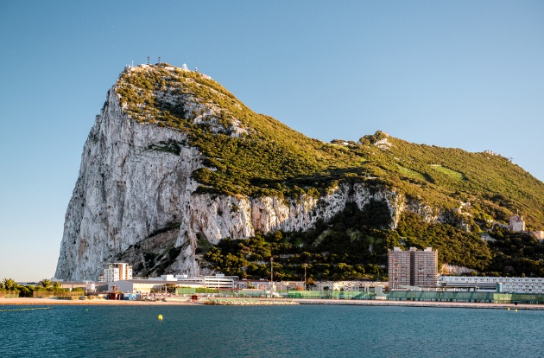
Q: Fill in the blanks with the help of the given indicators. makrs 6
Time: 5 mins
Roman Empire Jesus Christ three hundred roman religious Jewish religious Byzentine 33CE Constantine 53CE

Christianity originated in Palestine, than a part of the ____________________, and it was the Roman Governor of Judea who, in ___________, ordered the crucifixion of Jesus Christ (Hazrat Isa A.S), under the pressure of the ___________________leaders. However, the faith become popular with the poor, the slaves, and the people who were dissatisfied with the Roman religion. For the next _________________ year, Christians faced cruelty and persecution in the Roman Empire. Christianity found favor when ________________, the Byzantine emperor (306- 337ce) converted to the religion, and many churches were built by him. By the time Constantine died, Christianity had become the official religion of the _______________ Empire.
Q: Time line makrs 10
Time: 5 mins
Roman Kingdom _______________________
____________________ 509 – 31BCE
Roman Empire ________________________
___________________ 306 – 337CE
Khulafa – e – Rashidun ________________________
____________________ 661 – 750
The Abbasids ________________________
_____________________ 632 - 634
Hazrat Umer (R.A) ________________________
______________________ 644 – 656
______________________ 656 – 661

Q: Written Source
Page # 53 Arabia before Islam marks: 05
Time: 10 - 12 mins
Although the kaabah (house of Allah) ----------------------------------------------------------------------------------------------Arabian society living in the seventh century.
Read the above mentioned paragraph and answer the following questions
- Who built Kaabah?
- In which century, the message of Islam was brought to Arabia by Holy Prophet (PBUH)?
- Why the era was known as the “Age of Ignorance” before the advent of Islam?
Source 2: Page # 50 marks 06
Time: 10 -12 mins
Their (Roman) cities were well planned and houses ------------------------------------------------------------------------------------------were there for the people to enjoy.
Read the extract and answer the questions
- “Romans were good engineers”
Under the above mentioned statement narrate why it is said so?
- What were “aqueducts” and why these were constructed?
- Narrate two facts about “Colosseum.”

Section B
Question for 4 marks
Instructions:
- All the questions need to be done at the back side of the learning Journal
- TIME SPAN for each question is 7 - 10 minutes (strictly followed)
- Answer should be in a paragraph
- At least 4 valid points should be mentioned to support the answer.

- Write a brief note on the religion of Ancient Greeks.
- Why the Greece is considered the “Cradle of Western Civilization?”
- Who were the “Legionaries” and what was their function?
- What was the response of Romans towards Christianity?
- Who was Constantine?
- What is the appeal of message of Islam?
- Who was Hazrat Usman (R.A)?
- Who was Hazrat Ali (R.A)?
- Who was Muhammad Bin Qasim?
Question for 6 marks
Instructions:
- All the answers need to be done at the back side of learning journals
- TIME SPAN for each question is 12 - 14 minutes. (Strictly followed)
- Answer should be in TWO paragraphs.
- Answer should have proper identification, explanation, reference (2 marks for each)

- Explain what were the contribution of Ancient Greek to the most of the modern world?
- How far do you think, were the ancient Greeks really a democratic? Elaborate.
- Explain the reasons of Roman Empire division into two, Western and Eastern Rome?
- Explain with examples, why Abbasid khilafat was known as the Golden Age of Muslims?
- Elaborate the importance Dome of the Rock Mosque in Jerusalem?
- Write down the features of Muhammad Bin Qasim’s rule over Sindh and its impact?
- Elucidate Muslim inventions of Umayyad and Abbasid Khilafats.

