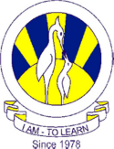
The City School
University Road Campus
History
Question Bank
Name: ___________________ Class: 6 Section: _______ Date: ______________
Section A
Q: Picture Source
Page 63 Fig 12.2 makrs 5
Time requires 10 min
- Name the place shown in the picture?
- Describe its current location.
- Why it is famous for?
- Who destroyed it and when?
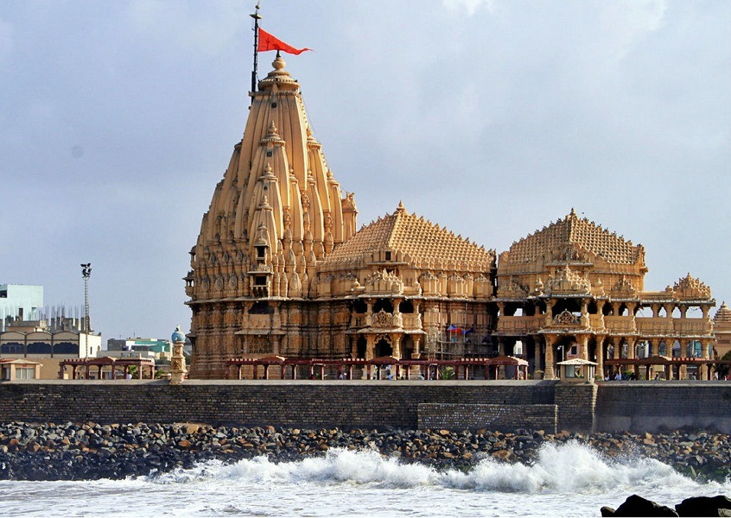
Q: Written Source
Page # 63 - 64 Al – Beruni (970 – 1030) marks: 05
Time: 10 - 12 mins
Abu Rehman Al – Beruni had come with ---------------------------------------------------------------------------------------------------------. It is widely read to this day.
Read the above mentioned paragraph and answer the following questions
- Who was Al – Beruni?
- Why did he came to India?
- Why Al – Beruni is famous for?

Section B
Question for 4 marks
Instructions:
- All the questions need to be done at the back side of the learning Journal
- TIME SPAN for each question is 7 - 10 minutes (strictly followed)
- Answer should be in a paragraph
- At least 4 valid points should be mentioned to support the answer.

- Briefly describe the different opinion of historians about Mehmud of Ghori?
- Who were Mongols? Why did they invaded India?
Question for 6 marks
Instructions:
- All the answers need to be done at the back side of learning journals
- TIME SPAN for each question is 12 - 14 minutes. (Strictly followed)
- Answer should be in TWO paragraphs.
- Answer should have proper identification, explanation, reference (2 marks for each)

- Why were the first Sultans of Dehli known as “Slave Dynasty?”
- “As a Sultan, he proved to be a wise or just ruler”. Under the given statement describe the achievements of Qutbuddin Aibak.

