The City School
University Road Campus
Grade 6
Geography
Question Bank

Instructions:
Use the back of your copy for writing your answers.
Avoid copying text as it is from the book. Always rephrase.
Please remember that these questions are meant for practice only so the students will be able to prepare themselves for examination point of view.

Natural Vegetation
Time Duration = 15 Minutes
Q1.a. “Wood is important for us”. Identify 4 ways in which the given statement is proven right. /2
b. Explain the processes numbered 1 to 5 in the given picture /5
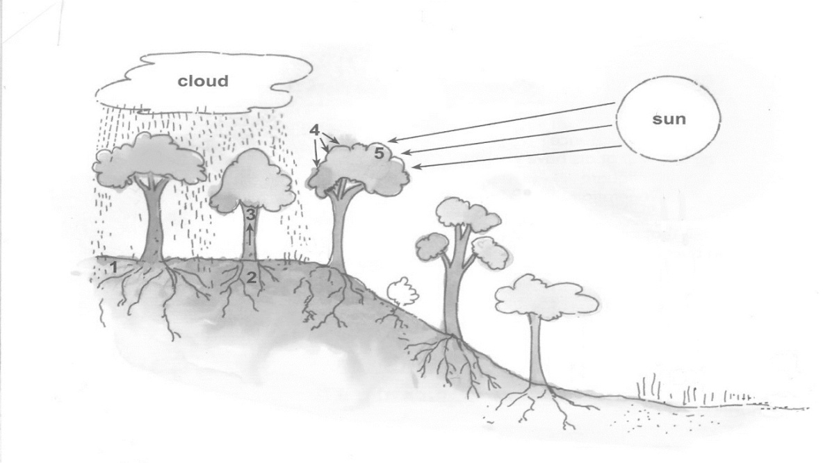

c. “Natural vegetation has its own impact”. Discuss how? /3
Agriculture
Time Duration = 15 Minutes
Q1a.Year 2015 was declared as the International Year of Soil. What steps were taken by United Nations for this purpose? /3

b. “Agriculture is the backbone of Pakistan’s economy.” Assess the importance of agriculture on the economy of Pakistan. /4
c. Why do you think livestock farming is significant? /3
Time Duration = 15 Minutes
Q2a. i. List the 2 non- food crops for human which is used as fodder crop for farm animals /3
_______________ ___________________ __________________
ii. Name two types of crops in terms of season /2
b. Identify 4 chief crops of Pakistan /2
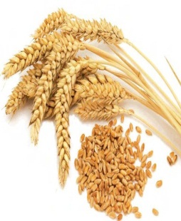
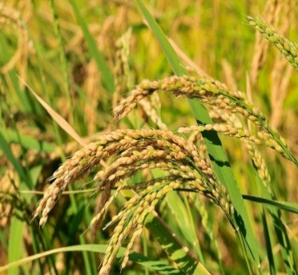
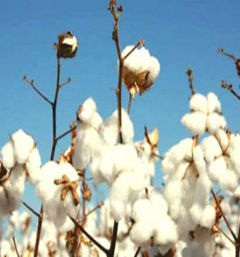
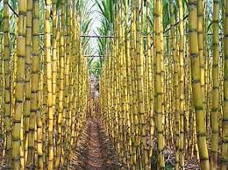

______________ _______________ __________________ __________________
c. Explain the process of cultivating rice with the help of flow chart given /5

Time Duration = 15 Minutes
Q3a. Differentiate between Small scale arable farming and large scale commercial arable farming. /3
b. Describe the features of shifting cultivation. /3
c. Explain why subsistence farmers remain poor as compared to small scale or large scale farmers through the diagram. /4

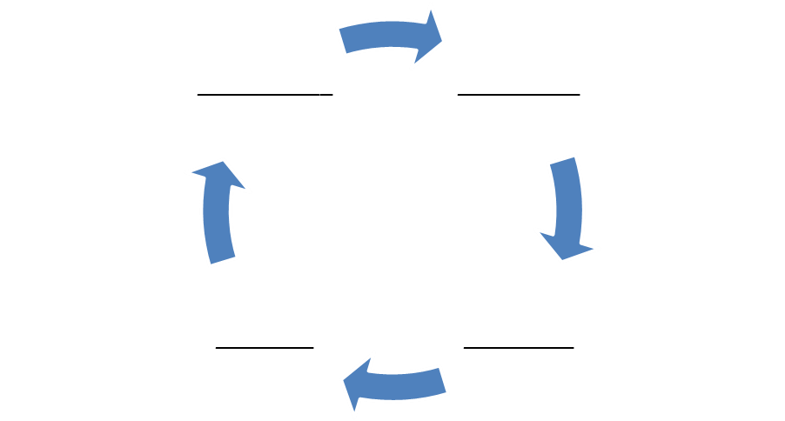
Read the book and answer the given question:
Time Duration = 15 Minutes
Q4a. Complete the table by using the words given below. /5
Capital threshing Banana Seeds Fertilizer Harvesting Hill rice livestock Egg
Ploughing Mango Tractor Labor Transplanting Threshing

Input | Output | Process
b. Why does Singapore use “high-tech” methods or soilless cultivation? /3
c. Differentiate between Hydroponic methods and aeroponic methods /2

