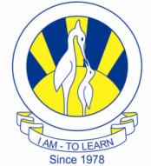
The City School
University Road Campus
Comprehensive Tasks English Class: 8 Dates: 16th -20th March,2020
Day 1:
Topic: Literature: Hobbit Chapter 16 ( A Thief in the Night) Duration: 40-50 minutes
Instructions: Go through the chapter’s reading and attempt the following questions:
- What does Thorin vow to do to anyone who withholds the Arkenstone?
- Who was the "thief in the night"?
- How was Bilbo able to escape?
- Why did Bilbo give the Arkenstone to the Bard?
- Who delights Bilbo with his presence just as the hobbit is preparing to depart the camp for his return to the Mountain?
- How does Bilbo defend himself when Thorin blames him for stealing the Arkenstone?
Day 2:
Topic: Grammar: Direct & Indirect Speech Duration: 40-50 minutes
Direct Speech: The message of the speaker is conveyed or reported in his own actual words without any change.
Indirect Speech: The message of the speaker is conveyed or reported in our own words.
Tips and Rules:
1. All inverted commas or quotation marks are omitted and the sentence ends with a full stop.
2. Conjunction ‘that’ is added before the indirect statement.
3. The pronoun ‘I’ is changed to ‘she’. (The Pronoun is changed in Person)
4. The verb ‘am’ is changed to ‘was’. (Present Tense is changed to Past)
5. The adverb ‘now’ is changed to ‘then’.

Examples on Process of Conversion from Direct to Indirect Speech
a) Direct: Salma said, “I am very busy now.”
b) Indirect: Salma said that she was very busy then.
a) Direct: He said, “I am unwell.”
b) Indirect: He said (that) he was unwell.
a) Direct: "I am reading a book", he explained.
b) Indirect: He explained that he was reading a book.
a) Direct: He said, “Ira arrived on Monday."
b) Indirect: He said that Ira had arrived on Monday.
a) Direct: He said, "I will be in Lahore, tomorrow."
b) Indirect: He said that he would be in Lahore, the next day.
a) Direct: He said, "I can swim."
b) Indirect: He said that he could swim.
a) Direct: He said, "I may buy a house.”
b) Indirect: He said that he might buy a house.
MUST changes into HAD TO/WOULD HAVE TO
a) Direct: He said, "I must work hard.”
b) Indirect: He said that he had to work hard.
a) Direct: He said, “Will you come for the meeting?”
b) Indirect: He asked them whether they would come for the meeting.
a) Direct: “Where do you live?” asked the girl.
b) Indirect: The girl enquired where I lived.
a) Direct: Ali said to Ahmed, “Go away.”
b) Indirect: Ali ordered Ahmed to go away.
c) Direct: He said to her, “Please wait.”
d) Indirect: He requested her to wait.
a) Direct: He said, “Alas! I am undone.”
b) Indirect: He exclaimed sadly that he was broken
a) Direct: He says to them, "You have completed your job.”
b) Indirect: He tells them that they have completed their job.
a) Direct: She said, “My father came yesterday.”
b) Indirect: She said that her father had come the day before.
a) Indirect: He asked whether he is coming.
b) Direct: He said to him, “Are you coming?”
Task #1: Spot the Errors:
Each of the following sentences will contain a mistake in the usage of Direct and Indirect Speech. See if you can spot that mistake.
1.Direct: The boy said, “I’m happy with my results.”
Indirect: The boy said that he is happy with his results. (Incorrect)
2.Direct: She said, “I have baked a cake.”
Indirect: She said (that) she baked a cake. (Incorrect)
3.Direct: He said, “All people have equal rights.”
Indirect: He said that all people had equal rights. (Incorrect)
4.Direct: Roshni said, “I may meet him here”.
Indirect: Roshni said that she may meet him here. (Incorrect)
5.Direct: She says, “I will go to school tomorrow.”
Indirect: She says that she would go to school the day after. (Incorrect)
6.Direct: He said, “She is coming this week to discuss this.”
Indirect: He said that she was coming this week to discuss this. (Incorrect)
7.Direct: He said to them, “Will you come for dinner?”
Indirect: He said to them will they come for dinner? (Incorrect)
8.Direct: The teacher said, “Be quiet and listen to my words.”
Indirect: The teacher said them to be quiet and listen to my words. (Incorrect)
9.Direct: The old man said, “Ah! I am ruined.”
Indirect: The old man said that Ah he was ruined! (Incorrect)
Task #2:
Select any 2 Direct Speech(1st Person Narrative) paragraphs from OPE Unit #6 Autobiography and convert them into Indirect Speech. (pgs #138-140)

Day 3:
Topic: Writing: Poetry Writing Duration: 40 minutes (1 pd)
Task #1:
Read 2 to 3 Poems from your OPE pgs# 108-109,173.174,184 and analyze them as per following questions:
1.What are the poetic devices you have noticed in them?
2. How the themes and messages being conveyed through them? Mention.
Task #2:
Create a Poetry of your own, having 6 to 7 stanzas, keeping the success criteria in mind.
Note: Poetry should be depicted centrally aligned, to be decorated according to your theme.
Marking Grid
Content | /03
Lay out | /01
Grammar/Punctuation | /02
Spelling | /01
Expression | /01
Total | /08

Day 4:
Topic: Grammar: Prepositional Phrases Duration: 40 minutes
A prepositional phrase is a group of words consisting of a preposition, its object, and any words that modify the object. Most of the time, a prepositional phrase modifies a verb or a noun. ... At a minimum, a prepositional phrase consists of one preposition and the object it governs.
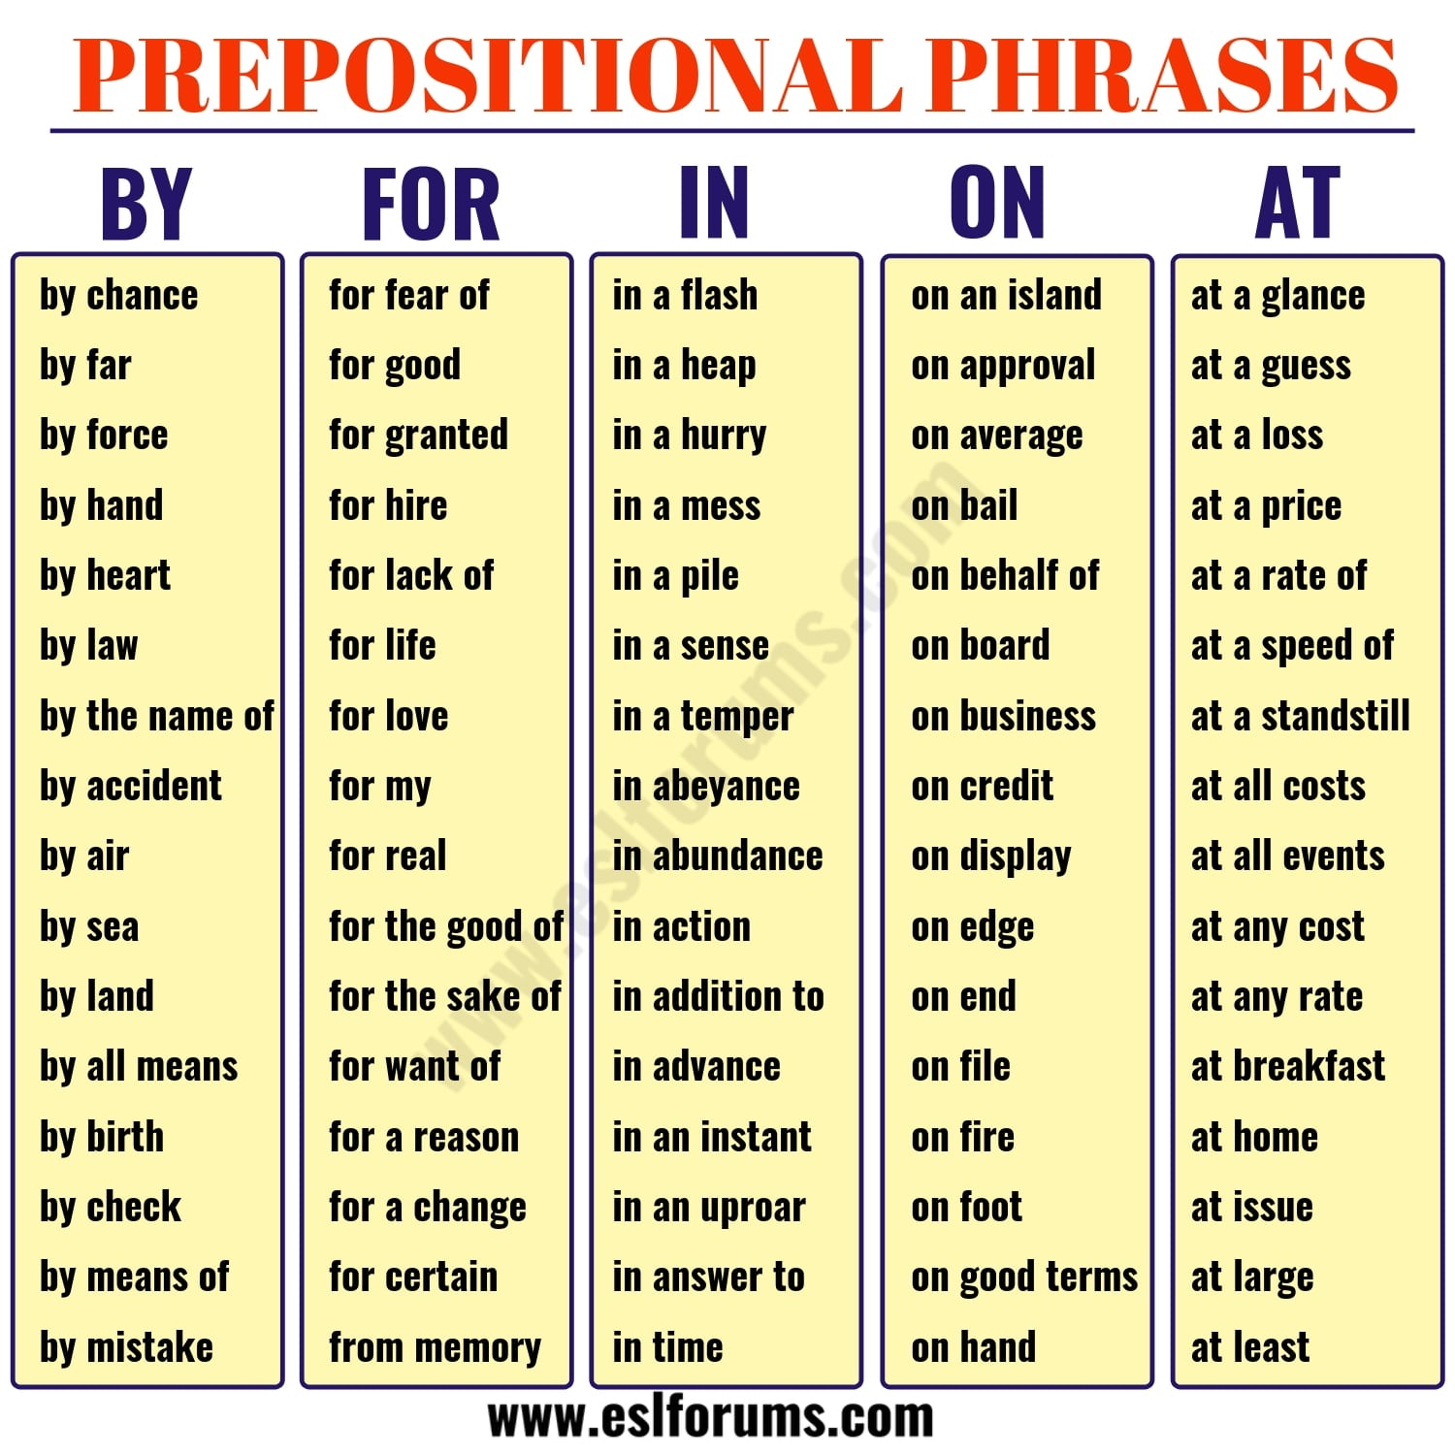
Starter Task: Read OPE pg #39 (Prepositions and its usage)
Browse and watch the following links:
https://www.proprofs.com/quizschool/
story.php?title=prepositional-phrase-test
Task #2:
Attempt the exercises and writing task from OPE pg #189-191

Day 5:
Topic: Hobbit (Chapter 17- The Clouds Burst) Duration: 40 minutes
Instructions: After reading the chapter and taking out key points,answer the following questions, according to Blooms Taxonomy:
- How does Bilbo defend himself against Thorin's accusation that he has stolen the Arkenstone?
- Why were Dain's people refused entry to the Mountain?
- Why did the dwarf attack against the Bard and the Elvenking end as quickly as it had begun?
- What role does the hobbit play in this fierce battle?
- What is the "gleam in the gloom" and how does it turn the tide of the battle?
- What happens to Bilbo at the end of this chapter?

