
The City School

University Road Campus

Class 8

Math

Resource

Topic: Congruence and Similarity
Two shapes are congruent if they are exactly the same shape and size. Technically speaking, this means that all the side-lengths and angles are the same.
One way to understand this practically is to imagine yourself cutting two shapes out of paper. If you can make one of the shapes fit perfectly on top of the other shape (you’re allowed to flip the pieces of paper over and rotate them), then the two shapes are congruent.
Example: Identify two pairs of congruent shapes from the options below.
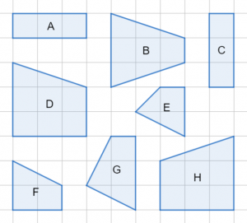
Looking at shape A, if we were to rotate it by 90\degree90° then it would fit perfectly onto shape C, so they must be congruent. Additionally, we can see that they’re both rectangles (so all angles are immediately the same) that are 1 square wide and 3 squares long. This is an extra clarification that they are indeed congruent.
For the second pair, looking at shape D, we can see that if we take the mirror image of it (which is the same thing as flipping over a paper cut-out), then the result will fit perfectly on top of shape H. Therefore, they must be congruent. It’s more difficult here to break down the individual angles and side-lengths to double-check the congruence like we did with the first pair but that’s okay – this was only an extra clarification, it’s sufficient to recognize that one fits on top of the other.
There is one shape that has its own special tests for congruence and that is the triangle. If we have two triangles which pass one of the 4 tests listed in bullet points below then they must be congruent. Each bullet point is a unique test: if two triangles have all 3 things listed on one bullet point in common, then that is enough to prove they are congruent. These 4 tests/criteria are:
- SAS – side, angle, side – two side lengths and the angle between them;
- ASA – angle, side, angle – two angles and the side length between them;
- SSS – side, side, side – all three side lengths;
- RHS – right-angle, hypotenuse, side – a right-angle, the length of the hypotenuse, and the length of one other side.
Each of these tests comes with its own acronym. You should be able to work out if two triangles are congruent and then state (by writing the acronym, e.g. SSS) which test you used to determine this.
Example: State which test you can use to prove that these two triangles are congruent.
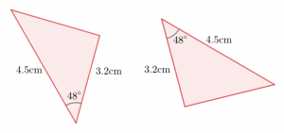
We can see that both these triangles have one side that is 3.2cm long, another which is 4.5cm long, and the angle between those two sides is 48\degree48° in both triangles.
In other words, this pair of triangles passes the SAS test for congruence.
Example: Determine which triangle(s) out of B, C, and D is/are congruent to A. State which test(s) for congruence you used.
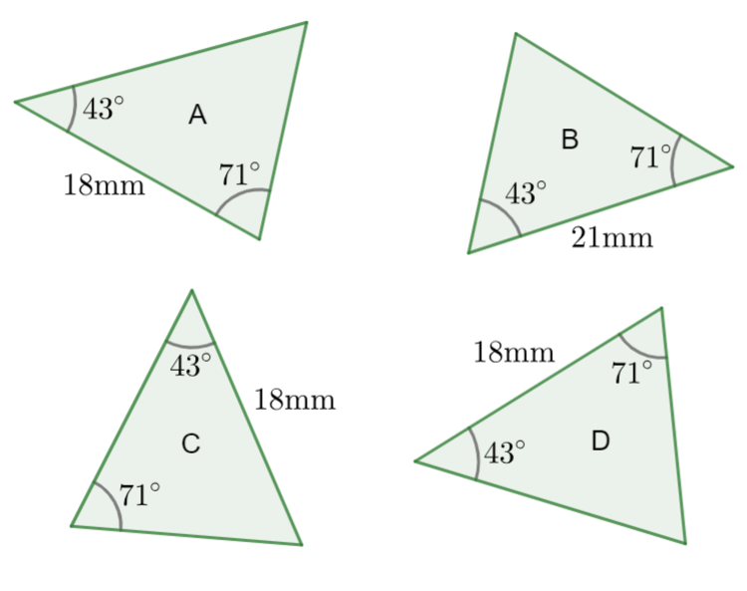
Let’s check each shape individually.
Shape B: it has two angles in common with A, but the side is a different length.
Shape C: this has two angles and a side-length in common with A, but to pass the ASA test the side-length needs to be between the two angles, which in C’s case it isn’t.
Shape D: this does what shape C didn’t – all the numbers match, and the side we know is between the two angles which means that shape D is congruent to A by the ASA criteria.
The real value in being able to spot when two triangles are congruent like this is that we suddenly know that all the other angles and side-lengths must also be the same. This is useful in making quick leaps towards solving bigger problems, for example in circle theorems, so keep the definition of congruence as well as the 4 tests for congruent triangles in mind when solving all kinds of geometry problems.
Assignment:
Workbook-2 Pg # 72-73 Q1-5

