The City School
University Road Campus
2nd Term
Science
Class 6
Topic: Habitats and Food Chains.
Q1. Choose the correct answer.
- _____________ is the gas given out from plants during photosynthesis.
  - Carbon dioxide
  - Nitrogen
  - Oxygen
  - Helium
- Plants produce food in the form of ______________________
  - Starch
  - Gas
  - Sugar
  - Light
- What is not needed by a plant to make its food?
  - Carbon dioxide
  - Soil
  - Light
  - Oxygen
- ‘Photo’ means ____________
  - Chlorophyll
  - Light
  - Sun
  - Water
- ______________ absorbs water from the soil.
  - Stem
  - Leaves
  - Flower
  - Roots
- Stomata are found on the _____________ of the leaves.
  - Top
  - Underside
  - Tip
  - None of the above
- ______________ Plants consume small animals or insects to get nutrients.
  - Insectivorous
  - Herbivorous
  - Normal
  - All of the above
- ______________ is formed when rocks wear down due to weathering.
  - Salt
  - Sugar
  - Starch
  - Soil
- _____________ type of soil contains a lot of nutrients
  - Clay
  - Loam
  - Sand
  - Slit
- ______________ fertilizers come from living things
  - All
  - Organic
  - Inorganic
  - None
- Some plants have _________ to help them climb and reach for sunlight.
  - Stems
  - Roots
  - Tendrils
  - Leaves
- Nocturnal animals have large eyes which are extra sensitive to __________.
  - Light
  - Sound
  - Movement
  - Texture
- ______________ occurs when pollen transfers from male part of flower to female part
  - Dispersal
  - Adaptation
  - Pollination
  - All of the above

Q2. Fill in the blanks.
- Water is absorbed by the plant from the soil or _______________.
- Photosynthesis cannot occur in the absence of ________________.
- ___________ is a green pigment which traps sunlight so l\plants can make food.
- Potato stores starch in its ____________.
- ____________ allows gases to enter or leave through the underside of a leaf.
- Sugar made by plants is mostly changed into ___________.
- _______________ solution can be used to test for the presence of starch
- The leaf of _______________ is divided into two halves and snaps shut to trap an insect that falls in it.
- The type of soil particles affects the ___________, air, water and ________________ of the soil.
- The type of soil usually found in gardens is _____________.
- _______________ fertilizers are also called chemical fertilizers because they are man made from chemicals
- Fertilizers provide __________ to the plant.
- The place where a living thing lives is its ________________.
- The habitat of a snail is a __________.
- The fruits of _______________ have hair-like structures to stick onto the fur or hair of passing animals.
- Plants depend on animals for ___________ which is provided after decomposition.
- Living things have _______________ which enhances their survival.
- The money plant can climb a tree and reach for more sunlight with the help of ________________.
Q3. How does a polar bear adapt to its environment for survival?

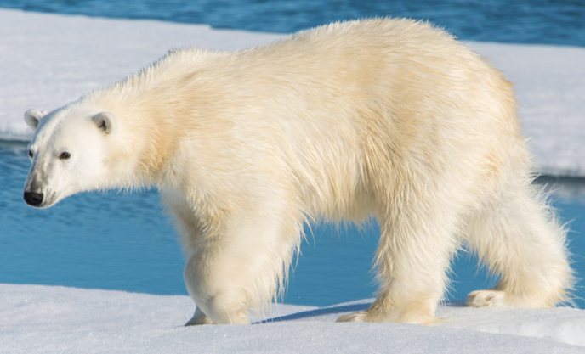
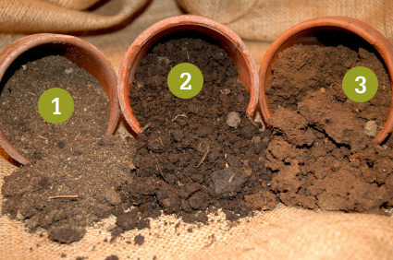
Q4. Observe the picture below and recognize the type of soil. Also answer the questions that follow.

- ______________
- ______________
- ______________
a-Which soil retains water well? _____________________
b-Which soil has high air content, and how does it affect the plant growth?
____________________________________________________________________________________________________________________________________________________________
c-Why is clay particles better suited for plant growth than sand particles?
____________________________________________________________________________________________________________________________________________________________
Q5. A potted plant is placed outside in the sun with one leaf covered in black paper. Minahil checks on the plant a few days later. Explain what she has tested for and what she will discover.
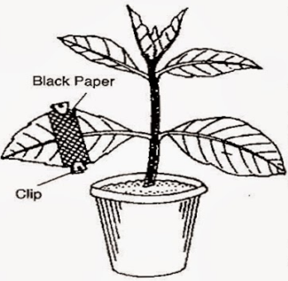
Hypothesis | Materials needed | Variables kept constant | Variables changed | Result

Q6. List the things important for plant growth.
- ______________________
- ______________________
- ______________________
- ______________________
Q7. Describe the role of fertilizers in plant growth.

Q8. How are plants and animals interdependent on each other for survival? Explain with example.
Dependence | Example
Animals depend on plants for food and energy.
 | Birds making nest on trees.
Plants depend on animals for reproduction.
 | Pitcher plant traps and digests insects to absorb their nutrients.

Q9. Write down the habitat of the following.
- Camel: ________________
- Shark: ________________
- Owl: ________________
- Vines: ________________

