
The City School
Self-Study Plan

Class: _____5_______________
Subject: Social Studies_________
Topic: Transport, telecommunication and trade____________
Date: 2nd – 6th March, 2020_____
Day 1:
Objectives:
Define the terms trade and transportation.
Methodology:
Explanation from the written source.
Trade: It is the buying and selling of goods.

Trade involves the transfer of goods or services from one person or entity to another, often in exchange for money.
Trade is defined as the general marketplace of buying and selling goods, the way you make a living or the act of exchanging or buying and selling something.
There are two types of trade:
Internal trade (within the country)
International trade (outside the country)
Factors which enhance trading:
- Transport
- Communication
Transport:
Take or carry (people or goods) from one place to another by means of a vehicle, aircraft, or ship.
Ask these questions:
  - What is trade?
  - Why do people trade?
  - What is the importance of trade?
  - How did people trade in the ancient times?

Day 2:
- Define the terms Imports and Exports.
- Define balance of trade.
- Name the exports of Pakistan.
- List the imports of Pakistan.

Methodology:
An import is a good or service bought in one country that was produced in another. Imports and exports are the components of international trade. If the value of a country's imports exceeds the value of its exports, the country has a negative balance of trade (BOT), also known as a trade deficit.

Exports are the goods and services produced in one country and purchased by residents of another country. If it is produced domestically and sold to someone in a foreign country, it is an export. Exports are one component of international trade.
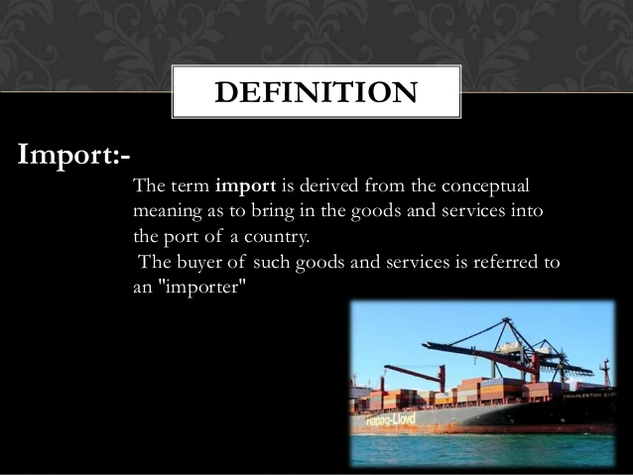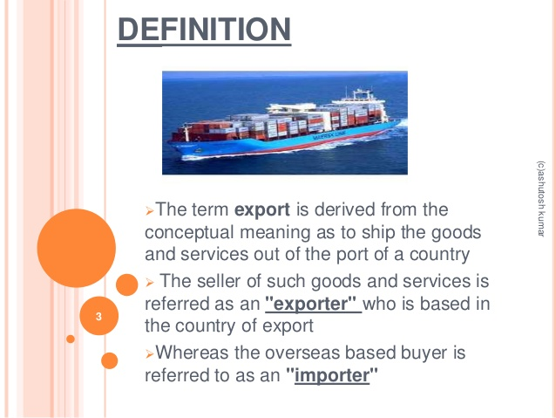
What is mean by balance of trade?
The balance of trade is the difference between the value of a country's imports and exports for a given period.

Favorable Balance of Trade. The value of a nation's exports in excess of the value of its imports.(Positive balance of trade)

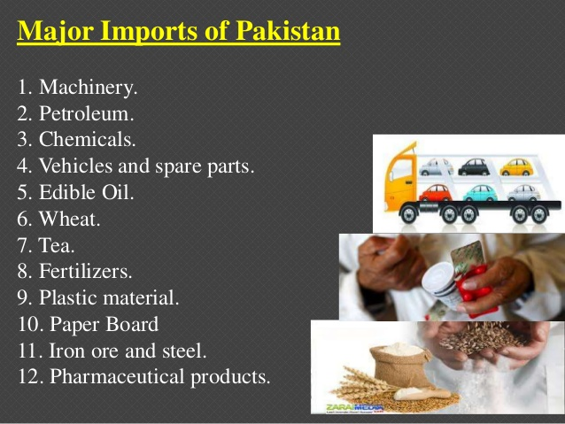

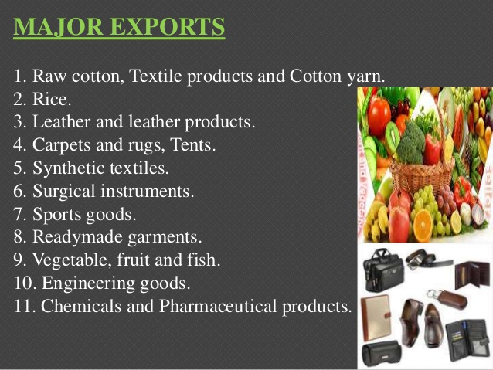

Day 2:
- Define the term trade.
- Name the exports of Pakistan.
- List the imports of Pakistan.

Methodology:
After the consolidation of the concept learners will do following questions:
- Define trade.
- Why trade is important for the development of the country?
- Make a list of imports and exports of Pakistan.

