
The City School
University Road Campus
Geography
Question Bank

Name: ___________________ Class: 8 Section: _______ Date: ____________

Topic: Power

Important Note: Please note that these questions are meant for practice, so that students will be able to prepare themselves for the examination.
Following are some key points to develop time management for EOY examinations
- 90mins/1:30min paper needs/can be done in 85mins
- 5min can be utilized for rechecking
- Each part of the question can be attended in 17mins duration.
- Student need to check and write the time they have utilized to attempt each question.
- While attempting blog question bank always utilize the back of the paper
- Avoid copying text from the book and always try to rephrase the sentences.

Q1.Study the photograph given below and the questions: ( /10marks)
Time ( /17mins)
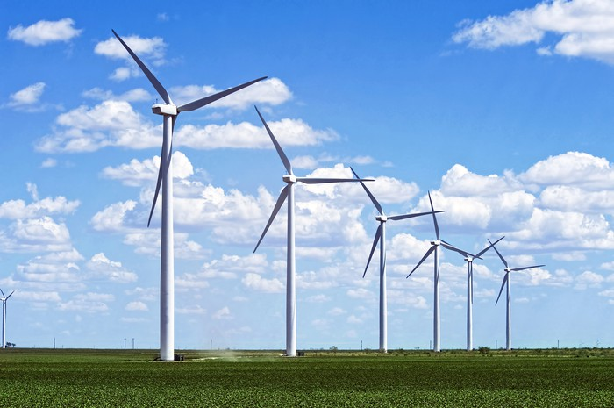

- (i) Name the type of renewable energies being generated . /1
(iiWrite two advantages of renewable energy. /2
- Write disadvantages of generating energy featured above in the photograph /3
- Why is it important for Pakistan to develop renewable power sources? /4
Q2. Answer to the given questions below. ( /10)
Time duration( /17min)
a. What is load shedding? /2
b. How does it affect industry and business in Pakistan? /4
c. Given reasons for low productivity of Power in Pakistan. /4

