
The City School
University Road Campus
Geography
Question Bank( Reinforcement for Study Plan)
Name: ___________________ Class: 8 Section: _______ Date: ____________

Topic: The World at War (1932-1945).

Important Note: Please note that these questions are meant for practice, so that students will be able to prepare themselves for the examination.
Following are some key points to develop time management for EOY examinations
- 90mins/1:30min 50mark paper needs/can be done in 85mins
- 5min can be utilized for rechecking
- Part A of the question can be attended in 20mins duration.
- Part B of the question can be attended in 65mins duration.
- Student need to check and write the time they have utilized to attempt each question.
- While attempting blog question bank always utilize the back of the paper
- Avoid copying text from the book and always try to rephrase the sentences.
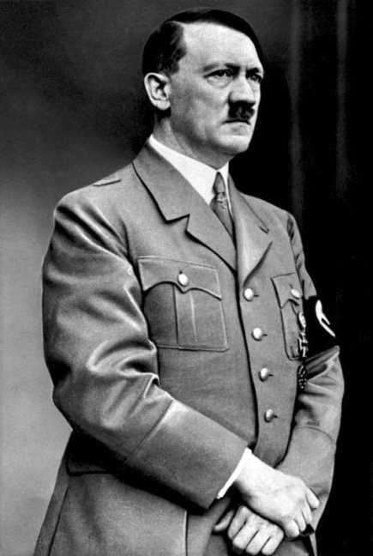
(Picture source)
Q1. Look at the picture source and answer to the given questions. ( /05marks)
Time ( /10mins)

- Identify the personality in the source /1
- How did he rise to power? /4
Sec- A ( Written source)
Q1.Refer to the facts of world war II from page no: 63 and answer to the given questions ( /05marks)
Time ( /10mins)
- Where was the highest loss of life and why? /2
- Explain why the destruction is called as immeasurable? / 3

