
The City School
University Road Campus
Reinforcement Worksheet
Mathematics
Class 7
Topic: Angle Properties of Triangles

Name: _________________________ Section: _____ Date: __________
Time: ___________

Q 1 Encircle the correct option.
- Which of the following can be true for a triangle
- Each angel is less than 60º
- Each angle is greater than 60 º
- Each angle is equal to 60 º
- 2 angles are obtuse angles
- Sum of interior angles in a triangle is
- 90 º
- 180 º
- 360 º
- 270 º
- Sum of angles on a straight line is
- 90 º
- 270 º
- 180 º
- 360 º
- In isosceles triangle the angles on the base are
- Equal
- 90
- Different
- None of the above
- In a right angle triangle, one of the angles is 32º, which of the following can be another of the angles in the triangle
- 148º
- 57º
- 58º
- 59º
Q 2 Fill in the blanks.
- A scalene triangle is one which has no ________ sides and no _______ angles.
- If two of the interior angles of a triangle are equal, the triangle is _____________.
- The sum of adjacent angles on a straight line is ______.
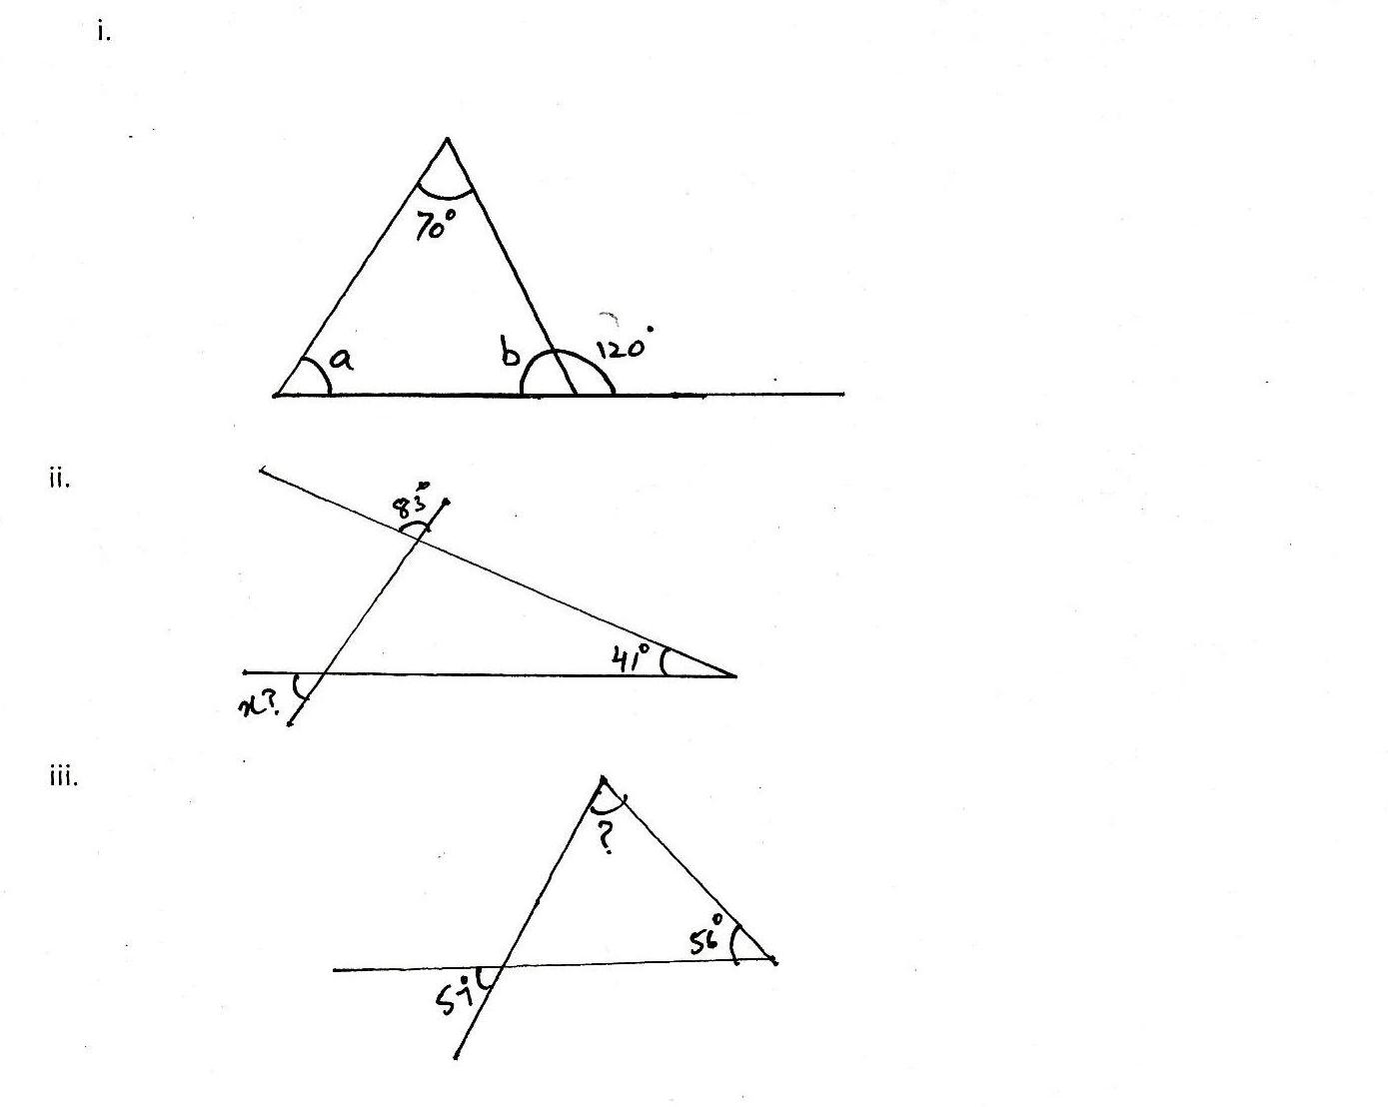
Q 3 Find each angle marked with a letter. Also give reason for your answer.

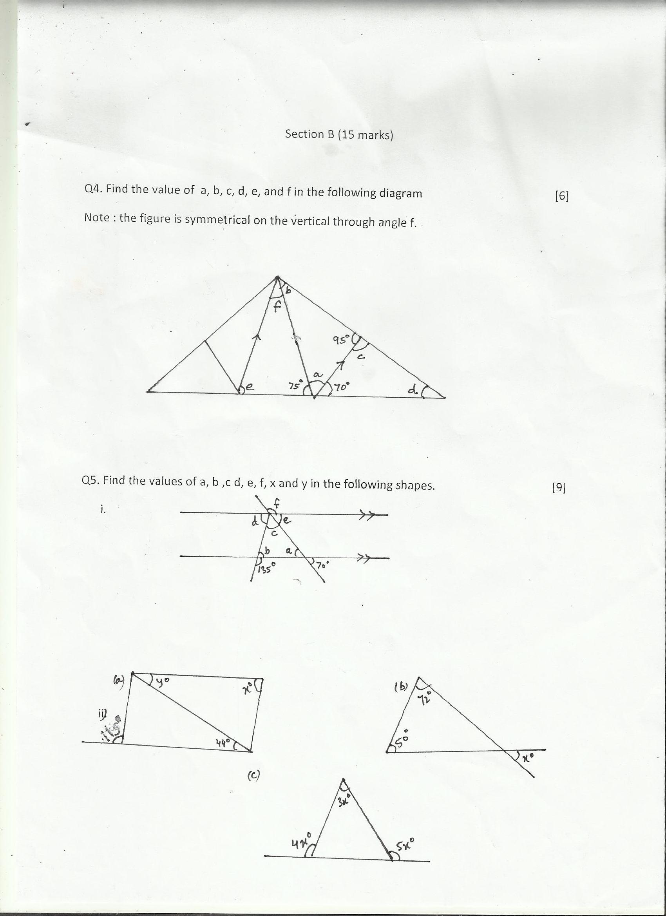
Q 4 Find the value of the unknown angles in the given figures. [The figure is symmetrical on the vertical through f]

Q 5 Find the value of the unknown angles in the given figures.

Q 6 Find the value of the unknown angles in the given figures.

