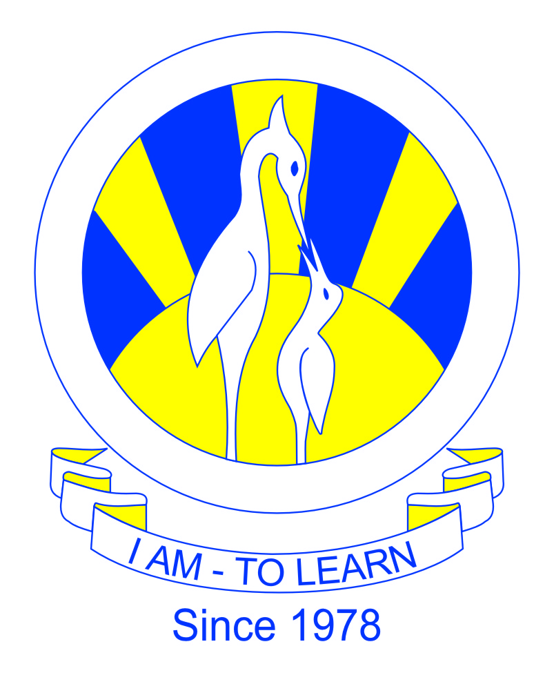
The City School
University Road Campus

Reinforcement Worksheet
Mathematics
Class 7
Topic: Volume and Surface Area

Name: _________________________ Section: _____ Date: __________
Time: ___________

Q1 Encircle the correct option.
- 500 litres is same as
- 5,000 cm³
- 50,000 cm³
- 500,000 cm³
- 500,0000 cm³
- 1 ml is equivalent to
- 0.1 cm³
- 1 cm³
- 10 cm³
- 100 cm³
Q 2 Fill in the blanks.
- 1000 cm³=_____litres
- There are _________ cm³ in a m³.
Q 3 Express 3600 ml in mm³.

Q 4 Find the width of a cuboid, if volume is 64cm³, length is 2cm and height is 8cm.
Q 5 If the surface area of a cube is 24cm², find length of a cube.

Q 6 An open rectangular tank of length 12 cm, width 8 cm and height 16 cm contains water up to a height of 8 cm. Calculate:
- The volume of water in litres ;
- The total surface area of the tank that is in contact with the water.
Q 7 The length is 8 cm, width is 12 cm and surface area is 426 cm² of a cuboid. Find;
- the volume and
- height
Q 8 Find the capacity in litres of a rectangular tank if the height of the tank is 0.15 m, length is 0.24 m and width is 0.19 m.
Q 9 Find the total surface area of a solid cube of volume 125 cm³

